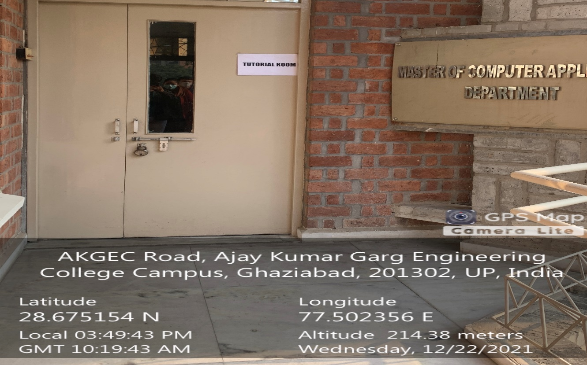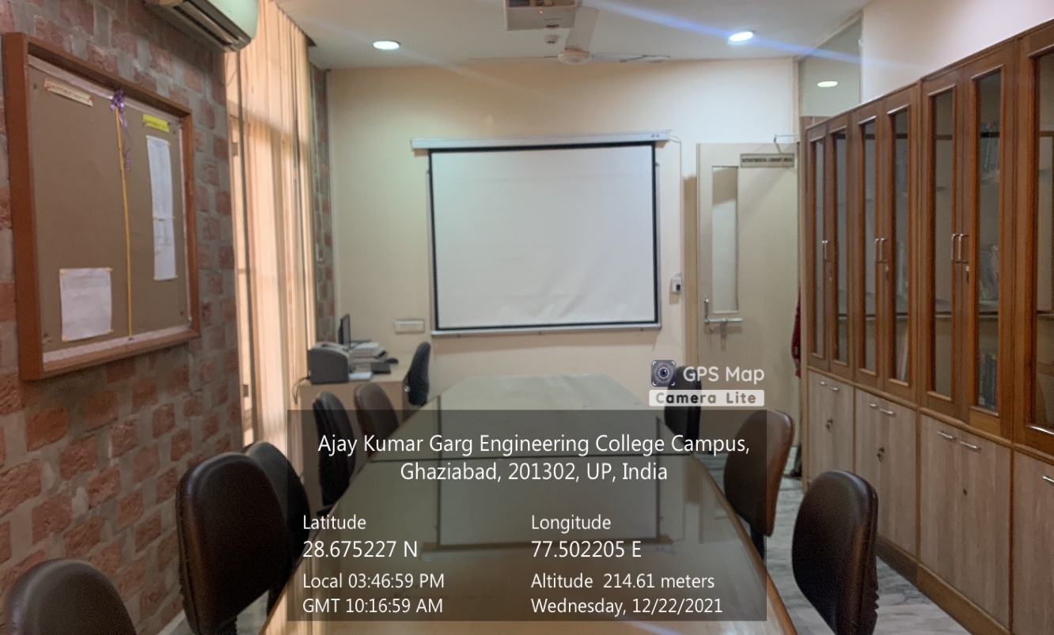

**MCA TUTORIAL ROOM**

**(Available Facilities: Projector, LAN, Wi-Fi, Sound System)**